Project Design Phase-II
Data Flow Diagram & User Stories

Date | 28 September 2026
Team ID | SWTID-2026-6339
Project Name | AI BlogNest
Maximum Marks | 4 Marks

Data Flow Diagrams:
A Data Flow Diagram (DFD) is a traditional visual representation of the information flows within a system. A neat and clear DFD can depict the right amount of the system requirement graphically. It shows how data enters and leaves the system, what changes the information, and where data is stored.
DFD Level 0 (Context Diagram)
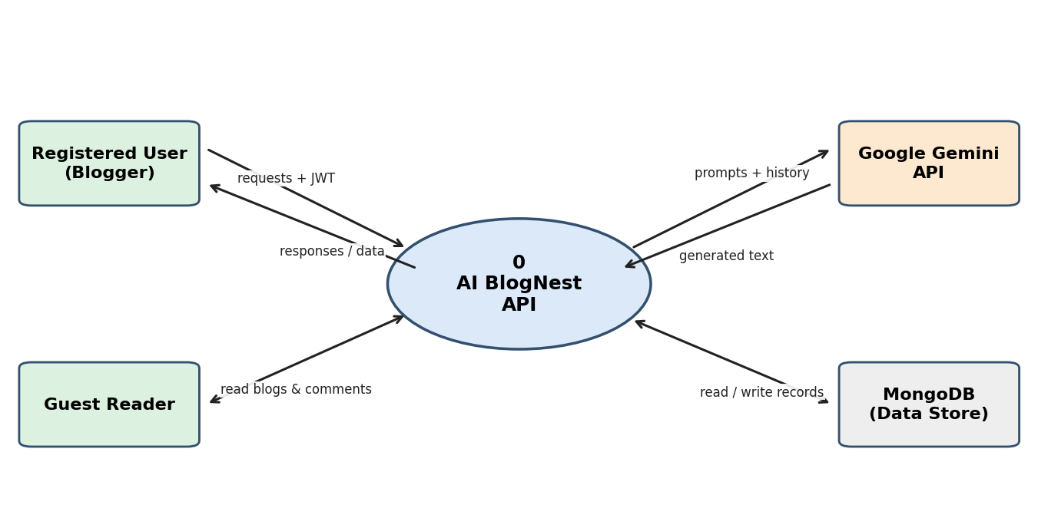
DFD Level 1
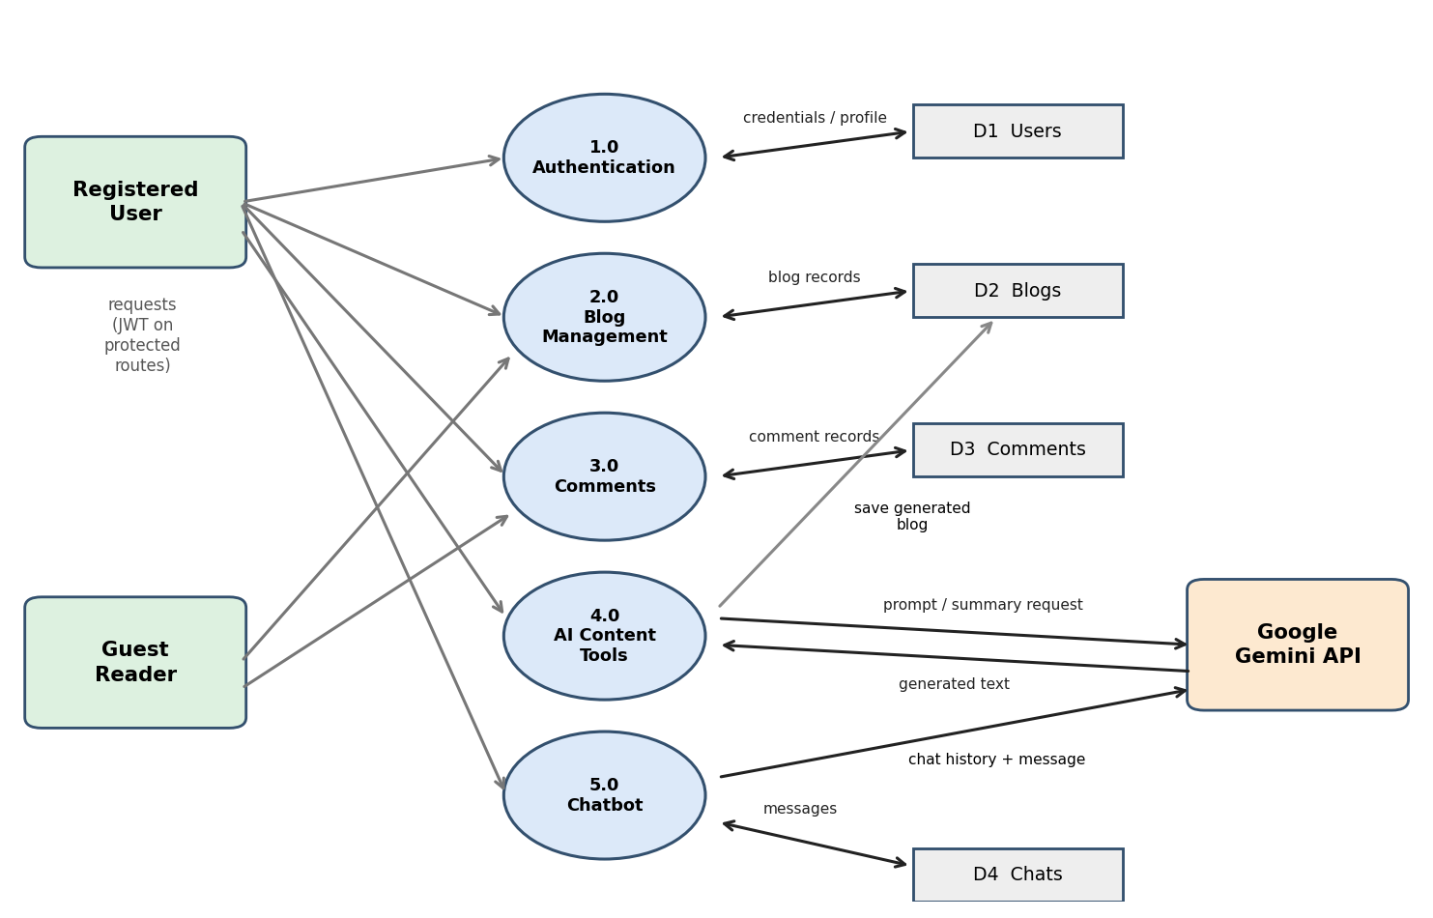

User Stories
Use the below template to list all the user stories for the product.
User Type | Functional Requirement (Epic) | User Story Number | User Story / Task | Acceptance criteria | Priority | Release
Registered User (Blogger) | Registration | USN-1 | As a user, I can register by entering my name, email and password (min 6 characters). | Account is created (201) and password is stored hashed | High | Sprint-1
 |  | USN-2 | As a user, I cannot register with an email that already exists. | API returns 400 'Email already registered' | High | Sprint-1
 | Login | USN-3 | As a user, I can log in with my email and password to receive a token. | Valid login returns a JWT; wrong credentials return 401 | High | Sprint-1
 |  | USN-4 | As a user, I can view my profile using my token. | GET /api/auth/profile returns my id, name and email | Medium | Sprint-1
 | Blog Management | USN-5 | As a user, I can create a blog with title, content and category. | Blog is saved with my ID and name (201) | High | Sprint-2
 |  | USN-6 | As a user, I can edit or delete my own blogs. | Update/delete succeeds for owner; others get 403 | High | Sprint-2
 | Comments | USN-7 | As a user, I can comment on a blog and edit or delete my own comments. | Comment saved (max 500 chars); non-owners get 403 | Medium | Sprint-2
 | AI Content Tools | USN-8 | As a user, I can enter a topic and get an AI-generated blog saved to my account. | Blog of about 100-150 words is created with a category (201) | High | Sprint-3
 |  | USN-9 | As a user, I can get a short AI summary of blog content. | POST /api/ai/summarize returns a summary paragraph | High | Sprint-3
 | AI Chatbot | USN-10 | As a user, I can chat with an AI assistant that remembers our conversation. | Reply returned and both messages saved to my history | High | Sprint-3
 |  | USN-11 | As a user, I can view and clear my chat history. | GET returns saved messages; DELETE empties history | Medium | Sprint-4
Guest Reader | Browse Blogs | USN-12 | As a reader, I can view all blogs (latest first) and open a single blog without logging in. | GET /api/blogs and /api/blogs/:id return data | High | Sprint-2
 |  | USN-13 | As a reader, I can read the comments on a blog. | GET /api/comments/:blogId returns comments | Medium | Sprint-2

